Table of Contents

How to Book 1

C++ 1

A. Vector 1

1.How to initial a vector? 1

1.1Create an empty vector 1

1.2Create a vector of size n with all values as 10. 1

1.3 initializing as arrays 1

vector<int> vect{ 10, 20, 30 } 1

1.4initializing from array 1

1.5initialize a vector from another vector. 1

2.Two-dimensional vector 1

3.sort a vector 1

B. Map 1

1.How to initial map? 1

2.How to insert to a map? 1

3.How to sort a map? 1

3.1by key 1

3.2by value 2

4.Find 2

Linked list 2

String 2

Stack 3

check overflow 3

Iterate 3

1.1 iterate from both sides at the same time 3

1.2 iterate 3

JAVA 4

1.How to return a two-dimensional array? 5

2.How to iterate a two-dimensional array? 5

3. How to iterate any Map in Java 5

# How to Book

# C++

# Format of DP:

State(所需状态)/initiate初始化/transform转移方程/return

# 1. Vector

## 1.How to initial a vector?

### 1.1Create an empty vector

    vector<int> vect;

    vect.push_back(10); //not vect[0]=10; as it is NULL

    vect.push_back(20); //as push_back, its size changes,we can check vect[i]

vect.push_back(30);

vect.insert(v.begin(),1)//insert 1 to the beginning

### 1.2 Create a vector of size n with all values as 10.

vector<int> vect(n, 10);

### 1.3 initializing as arrays

### vector<int> vect{ 10, 20, 30 }

### 1.4initializing from array

vector<int> vect(arr, arr + n);//n number of elements

### 1.5 initialize a vector from another vector.

vector<int> vect1{ 10, 20, 30 };

vector<int> vect2(vect1.begin(), vect1.end());

### 1.6 search an element in the vector

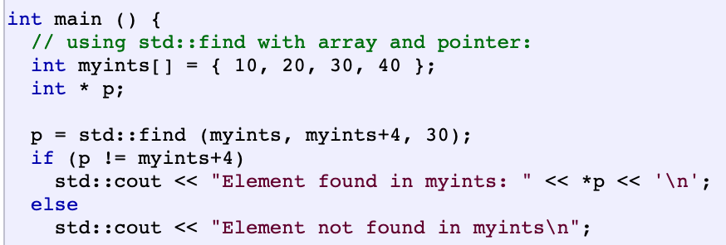

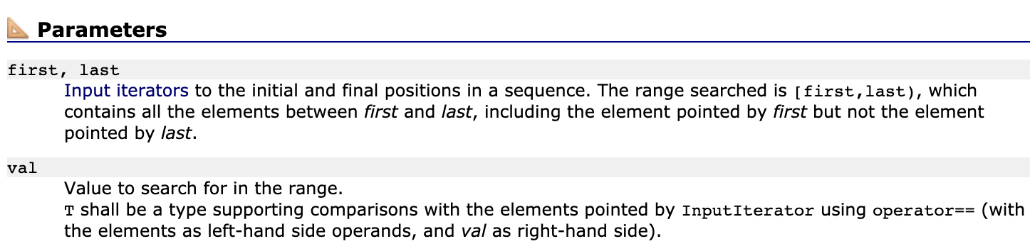

## 2.Two-dimensional vector

vector<vector<int>> num

vector<vector<int>> ct(m,vector<int>(n,0));

num.resize(nRows);//set a n row vector

num.back().push_back()

## 3.sort a vector

# 2. Map

## 1.How to initial map?

unordered_map<int, int> map;

unordered_map<char, int> T=

{{'I',1},{'V',5},{'X',10},{'L',50},{'C',100},{'D',500},{'M',1000}};

## 2.How to insert to a map?

map.insert(make_pair(target-nums[i], i));

## 3.How to sort a map?

### 3.1by key

sort(map.begin(),map.end());

### 3.2by value

## 4.Find

if(map.find(nums[i])!=map.end())

5.get value

For(auto e:map)

e.second;

# 3.Linked list

if(!l1) return l2;//if(l1==NULL)

# 4.String

String s;

s.back();

s[i];

to_string(int a)

s.length();//also ok for s.size();//strlen is in java

s1.compare(s2);//return 0,negative(shorter),positive(longer)

substr();

chat to int: s[i]-‘0’;

int to char:char(n+’0’)

|  |  |
| --- | --- |
| int main ()  {  std::string str="We think in generalities, but we live in details.";  // (quoting Alfred N. Whitehead)  std::string str2 = str.substr (3,5); // "think"  std::size_t pos = str.find("live"); // position of "live" in str  std::string str3 = str.substr (pos); // get from "live" to the end  std::cout << str2 << ' ' << str3 << '\n';  return 0;  } | [Edit & Run](http://www.cplusplus.com/reference/string/string/substr/) |

Output:

|  |
| --- |
| think live in details. |

Add number to string

string s="";

s+=to_string(5);

find something in the string

str.find_first_not_of(“ ”)寻找第一个不是whitespace的idx

str.find_last_not_of(“ ”)

eg:“ 42 ”2,3

sort string s: sort(s.begin(),s.end());

for(auto i=S.rbegin();i<S.rend();++i) // reverse iterator

stringstream:

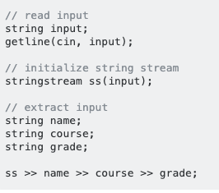 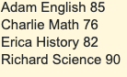

String s

s.split()

# 5.Stack

stack<char> p;

for(char &c:s){

switch(c){

case'(':p.push(c);break;

case'{':p.push(c);break;

case'[':p.push(c);break;

case')':if(p.empty()||p.top()!='(') return false; else p.pop();break;

case'}':if(p.empty()||p.top()!='{') return false; else p.pop();break;

case']':if(p.empty()||p.top()!='[') return false; else p.pop();break;

default:;

}

}

return p.empty();

# 6.array

Int arr[5]={1,2,3};//last two elements are 0

Int arr[]={1,2,3};

int baz [5] = { };//initial all of 0

both right. Do not need equal sign

|  |  |
| --- | --- |
|  | int foo[] = { 10, 20, 30 };  int foo[] { 10, 20, 30 }; |

# check overflow

while(res>0){

if(sum>(pow(2,31)-1)/10) return 0;

sum*=10;

sum+=res%10;

res/=10;

}

# Iterate

## 1.1 iterate from both sides at the same time

for(long i=0,j=res.size()-1;j>=i;i++,j--){

if(res[i]!=res[j]) return false;

}

## 1.2 iterate

for(int i=0;i<5i++){…}// outside the for loop, i became 5;

# DP vs Recursion

Dynamic Programming is a way to solve problems which exhibit a specific structure (optimal sub structure) where a problem can be broken down into sub problems which are similar to original problem. Clearly one can invoke recursion to solve a DP. But it is not necessary. One can solve a DP without recursion.

Memoization is a way to optimize DP algorithms which rely on recursion. The point is not to solve the sub problem again which has been already solved. You can view it as cache of solutions to sub problems.

[Dynamic programming](http://en.wikipedia.org/wiki/Dynamic_programming) is when you use solutions to smaller subproblems in order to solve a larger problem. This is easiest to implement recursively because you usually think of such solutions in terms of a recursive function. An iterative implementation is usually preferred though, because it takes less time and memory.

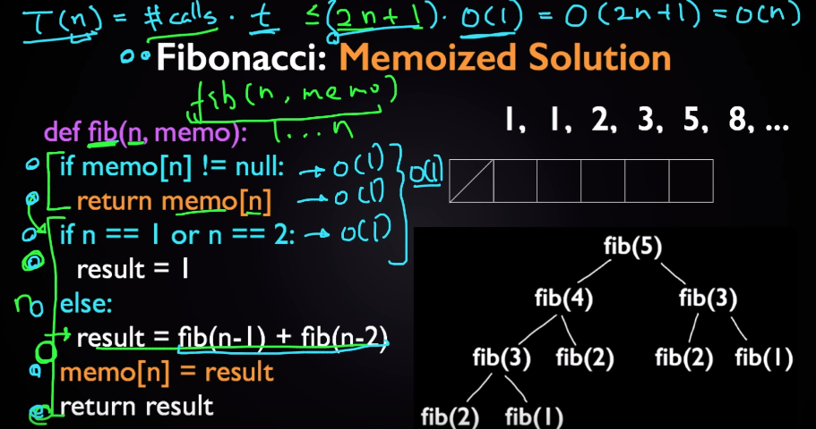

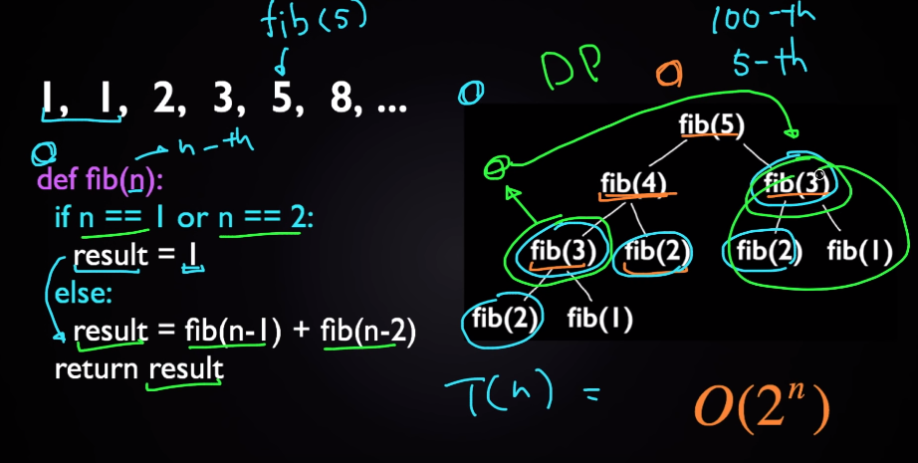

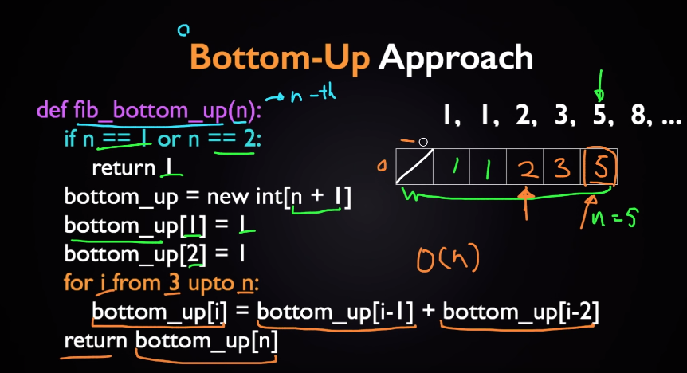

# JAVA

## 1.How to return a two-dimensional array?



## 2.How to iterate a two-dimensional array?



## 3. How to iterate any Map in Java



Python

Read lines to panda data frame

import sys, re, pandas as pd

data = sys.stdin.read().splitlines() # obtaining the list of lines from stdin

data = [re.split(r'\s+(?=\d+$)', l) for l in data] # split each line into 2 items: `city` and `value`/ split string and digits

// data = [re.split(' ', l) for l in data]/split by ‘ ’

df = pd.DataFrame(data) # constructing dataframe